Objective: Explain the movements produced at each joint and link to specific sporting actions (Merit).
Learning Aim A- The Skeletal System
CHALLENGE: Explore the role of the skeletal system during physical activity and link to sporting success. (Distinction)
Task 1 – Label and revise:
- The major bones of the skeletal system
- The vertebral column
- The construction of a synovial joint (knee)
- The Axial and Appendicular.

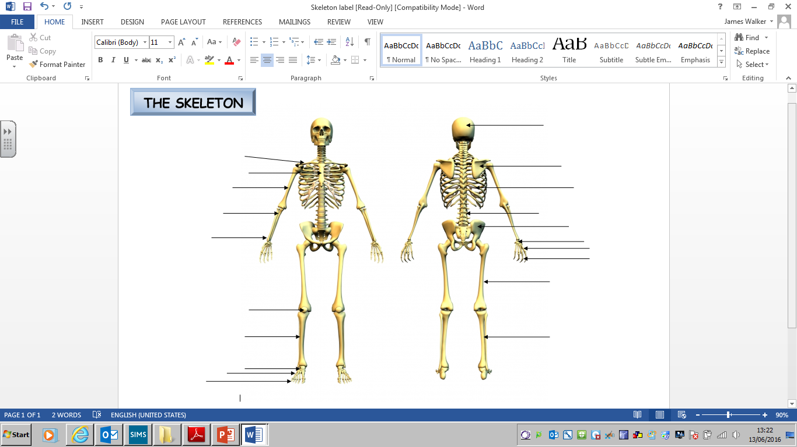

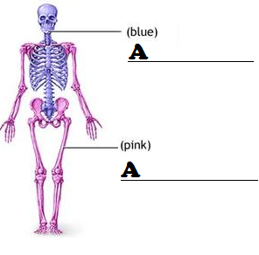

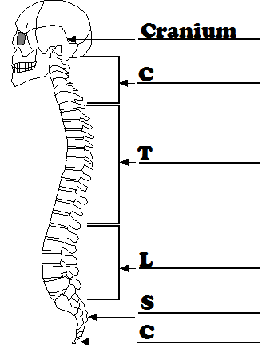
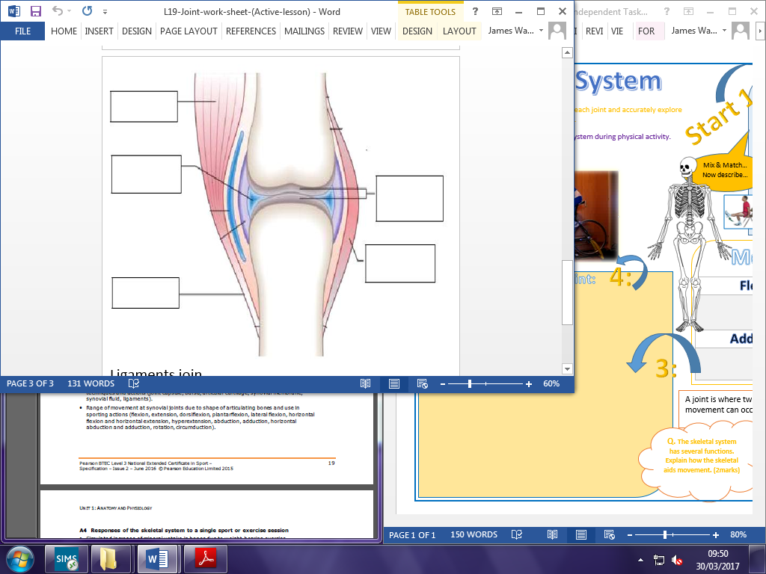

Task 2 – Label and revise: (Functions and movement)
- The functions of the skeletal system.
- The types of bones, with examples and there function in the skeleton.
- Joint movements and links to sporting actions.

- P_ _ _ _ _ _ _ _ _
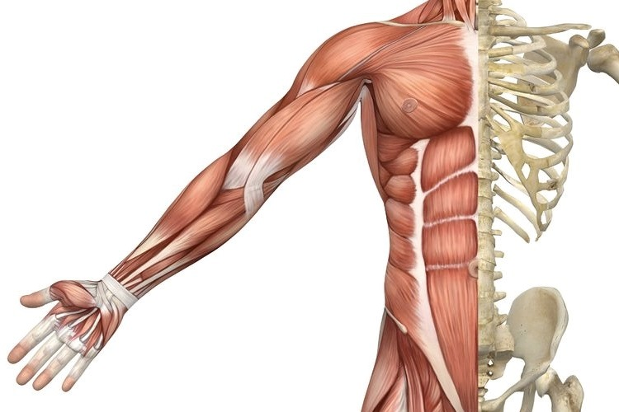

- _ _ P _ _ _ _

- _ _ A _ _

- M _ _ _ _ _ _ _

- _ _ O _ _ _ _ O _ _ _ _ _ _ _

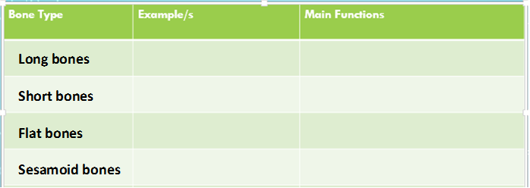
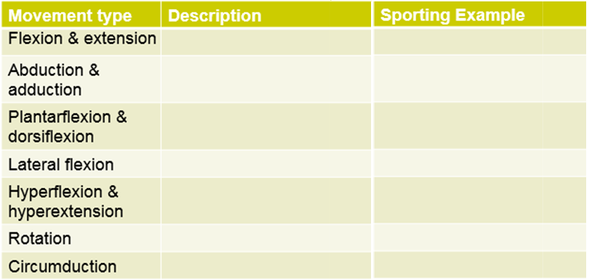
2:

EXAMPLE OF EXAM STYLE QUESTIONS

