KEY TERMS: RESPIRATION, ANAEROBIC, AEROBIC, TIDAL VOLUME, VITAL CAPACITY, OXYGEN DEBT

Objective Discuss the long term effects of exercise on the respiratory system

Challenge: Explain the process of breathing and how it affects sporting performance and success (link to specific sports)

C: THE RESPIRATORY SYSTEM

Describe the process of Gaseous Exchange
_________________________________________________________________________________________________________________________________________________________________________________________________________________________________________________________________________________
__________________________________________

Identify the immediate and long term responses to exercise on the respiratory system
_____________________________________________________________________________________________________________________________________________________________________________________________________________________________________________________________________________________________________________________________________________________________________________________________________________________________________________________________________________________________________________________________________________________________________

Asthma
Altitude/change in partial pressure

Explain the effects of the following;

Immediate responses to exercise

USE THE EXTRA SPACE ON THE BACK!

Label the Respiratory System
DEFINE THE FOLLOWING TERMS
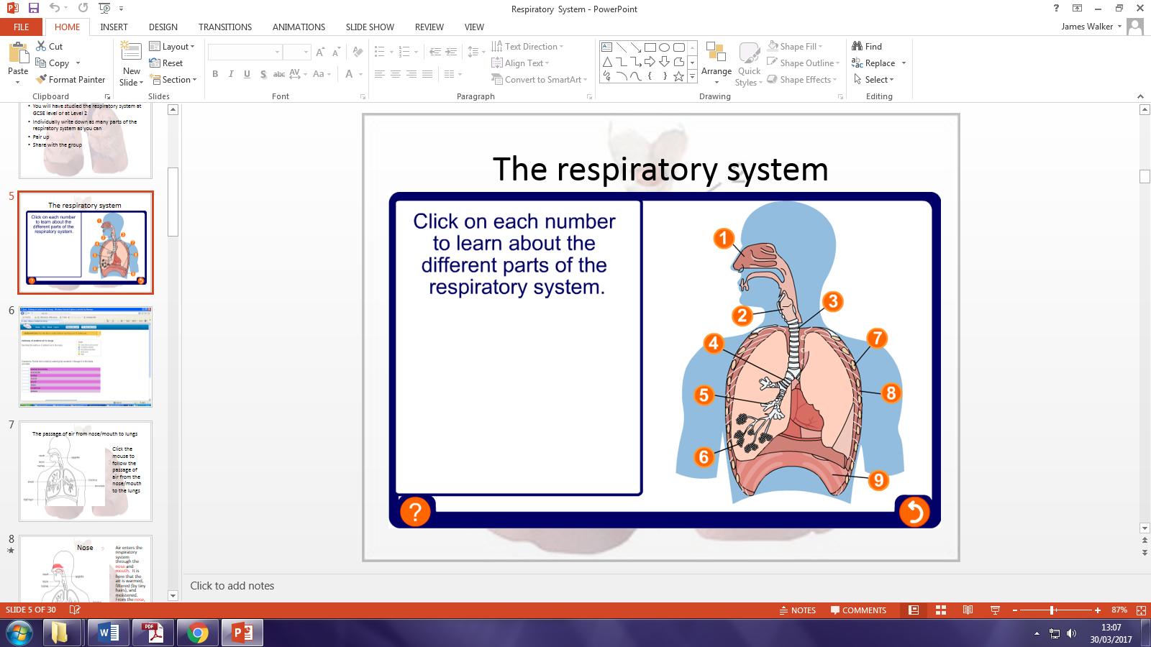
Tidal volume.
Vital capacity.
Residual volume.
Total lung volume.
Pulmonary ventilation (VE).

Describe and explain, using examples, both the immediate effects, and the long term effects of regular exercise on the respiratory system.
(6 MARKS)

EXTRA SPACE

